CFN 1039940 OR BK 2793 PG 1701

ARTICLES OF INCORPORATIOI'4

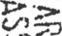
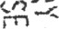

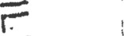
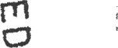
EAGLE BAY LANDING
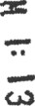
HOMEOWNERS ASSOCIATIOI4, INC.

The undersigned, Flynn D. Morris, the subscriber to these Articles of Incorporatiorg2J hereby executes these Articles of Incorporation to form a non-Stock corporation, not fOFQT under the laws of the State of Florida.
ARTICLE I. NAME AND ADDRESS
The name of the corporation is EAGLE BAY LANDING HOMEOWNERS ASSOCIATION, INC., hereafter called the ‘Association." The principal office of the Association and the street address of the initial registered office shall be 21 N. Spooky Lant, Santa Rosa Beach, Florida 32459; but may be changed to another place in Florida as designated from time to time by the Board of Directors. The name and addmss of the Incorporator is: Flynn D. Morris, 21 North Spooky Lane, Santa Rosa Beach, FL 32459.

ARTICLE TI. PURPOSE AND POWERS
The Association is not organized for pecuniary gain or profit to the members thereof,
and it shall be prohibited from any distribution of income to its members, directors, azid officers. The specific purposes for which it is formed arc to provi‹k for maintenance, preservation, and architectural control of ttie subdivision known as EAGLE BAY LANDING SUBDIVISION in WaJion County, Florida, according to the plat recorded in the public records of said cnunty, and the Declaration of Covenants, Conditions, and Restrictions, likewise recorded in the public meords of said county, and promote the health, safety, and welfare of the residents within the above-described property and any additions thereto as may hereafter be
brought within the jurisdiction of this Association for this purpose to (but only as the following may from time to time be permissible for corporations not for profit under the laws of Florida):
- exercise all of the powers and privileges and to perform all of the duties and obligations of the Assoéiation as eet forth in that certain Declaration of Covenants, Conditions and Restrictions, heminaficr called the •Declaretion,’ applicable to the property and to be recorded in the Office of Clerk of the Circuit Court of Walton County, Florida, and as the same may be amended from time to time as therein provided, said Declaration being incorporated hemin as if set forth at length;
- fix, levy, collect and enforce payment by any lawful means, all charges or assessments pursuant to the terms of the Declaration; to pay all expenses in connection therewith end ell ofTicc and other expenses incident to the conduct of the business of the Association, including all licenses. taxes, or governmental charges levied or imposed against the property of the Association;


CFN 1039940 OR BK 2793 PG 1702

- acquim (by sift, purchase or otherwise), owti, hold, improve, build upon, operate, maintain, convey, sell, lease, traiufer, dedican for public use or otherwise dispose of real or personal pmperty in connection with the affairs of the Association:
- borrow money, and with the ascent of two-thirds (2/3) of each class of members, mortgage, pledge, deed in trust, or hypothecate any or all of its real or personal property as security for money borrowed or debts incurred;
- dedicate, sell or transfer all or any part of the Common Ar°a to any public agancy, authority, or utility agreeing to hold and maintain the sami for such purposes. The
Association may grant easements over the Common Area to private parties, but no such easement shall be effective unless an instrument has been signed by two-thirds (2/3) of each class of members; unless the Declaration provides for such merger, consolidation or aiuiexation;
(g) have and to exercise any and all powers, rights, and privileges which a corporation organized under the Corporation Not Por Profit Law of the State of Florida by law may now or hereafter have or exercise.
ARTICLE III. MEMBERSHIP
Every penon or entity who is a record owner of a fee or undivided fee interest in any lot which is subject by covenants of record to assessment by the Association, including contract vendecs under a contract for deed, ahail be a member of the Association. The foregoing is not intended to include persons or entities who hold an interest merely as security for the performanceot en obligndon. Membership shall be appurtenunt to and may not be separated from ownership of any lot which is subject to assessment by the Association.
ARTICLE IV. VOTING RICrHTS
The Association shall have two classes of voting membership;
Ctass A. Class A member(s) shall be all Owners, with tht exception of the Developer, EAGLE BAY LANDING, LTD, and shall be entifled to one (1) vote for euch Lot owned.
When more than one person holds an internet in añy Lot, all such persons shall be members. The vote for such Lot shall be exercised as they dctemiine, but in no event shall more than one vote be cast with respect to any Lot.
Class B. Ths Class B membe(s) shall be the £kveloper, EAGLE BAY LANDING, LTD (as defined in the Declaration), and shall be entitled to three (3) votes for eech Lot owned. The Class B membership shall ceaec and be converted to Cleas A membership upon the termination of the Development Period (ai defined in the Declaration).

CFN 1 039940 OR BK 27 93 PG 1 703

ARTICLE V. BOARO OF D1RZCg'ORS
The affairs of this Association shall be managed by a Board of at least three (3) dimctors, who need not be members of the Association. The number of directors may be changed by amendment of the By-Laws of the Association but may not exceed nine (9) nor be less than three (3). The names and residence addresses of the persons who are to act in the capacity of directors until the selection of their successors are:
21 N. Spooky Lane
Santa Rosa Beach, FL 32459
Thomas J. Bryan
1819 Pepperell Parkway.
Opelika, AL 36801
Edward E. Rogers P O. Box t068
Fai&opc, AL 36533
Only thme (3) directors shall be required initially. At the first annual meeting, the members shall elect at least thme (3) directors and at each succeeding annual meeting, or at a special meeting cailed for the purpose of electing directors, the members shalt elect the number of dimctora, which may from time to time be designated by the By-Larva.
ARTICLE VI. DISSOLUTION
The Association may be dissolved widi the assent given in writing arid signed by not less than two-thirds (2/3) of each class of members. Upon dissolution of the Association, other than incident to a merger or consolidation, the assets of the Association shall be dedicated to an appropriate public agency to be used for purposes similar to those for which this Association was created. In the event that such dedication is refused acceptance, such assets shail be granted, conveyed and assigned to any nonprofit corporation, association, trust or other organization to be devoted to such similar purposes.

ARTIC •E VII. DURATION
The corporation shall exist perpetually.

ARTICLE VIII. AMENDMENTS
Amendments to these Articles shalt mquire the assent of two-thirds (2/3) of the entim membership. Amendments may be proposed by any member at any annuai meeting or special meeting calkd for that purpose, and adopted by the members, in punon or by proxy, at that or any subsequent meeting by the pemcmge of members set forth above. The By-Laws of the

3

CFN 1039940 OR BK 2793 PG 1704

“ corporation shall be made, altered, or rescinded, at a regular or special meeting of the members, by a vote of a majority of the niemben present in person or by proxy. The By-Laws may restrict the number of proxies to be voied by any person.

ARTICLE \X. OFFICERS
The affairs of tht corperution am to be managed by a President, Vice-President, Secretary, and Treasurer, who need not be members of the Association. They shall be elected at the fim meeting of the Board of Directors following each annual meeting of the members. The President and Vice-President shall be Directors. Until the first election of ofTlcers, Flynn
D. Morris, Jr. shall serve at President, Secretly and Treasurer and Edward E. Rogers shall scan: zs Vice-President of the corporation.
ARTICLE K. SUBSCRIBER
The subscriber lo these Articles of Incorporation and his address is Flynn D. Morris, ir., 21 North Spooky I-ane, Santa Ross Beach, FL 32459.
ARTICLE XI. INITIAL RESIDENT AGE IT AND OFFICE
William S. Howell, Jr., J.D., P.A., whose office address is 1727 S. County Highway 393 Santa Rosa Beach, Florida 32419, is htreby appointed as the initial Resident Agent of the corporation, and the office of the corporation shall be at that address until another is properly designated pwsuant to the then applicable law.
ARTICLE XII. INDEMi ITY
Every officer of the Association shall be indemnified by the Association against all expenses and liabilities, including counsel fees, reasonably incurred by or opposed upon him or her in connection with any proceedings to which he or she may be a party or in which he or she mey become involved, by reason of his or her being or having bten an officer of the Association whether or not he or she was on officer at tht time such expenses are incurred, except in such cases whemin the officer is adjudged guilty of willful misftasance or malfeasancc in the performance of his duties. The foregoing right of indemnification shall be in addition to and nor exclusive of all other rights to which eny such officer may be entitled.
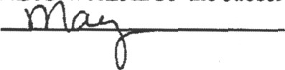
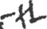
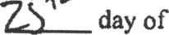
IN WITNESS WHEREOF the subscriber has ecuted this ins cut this.
, 2

ORRI ., Incorporator

CFN 1039940 OR BK 2793 PG 1705

9TATE OF FLORIDA
COUNTY OF TALTON
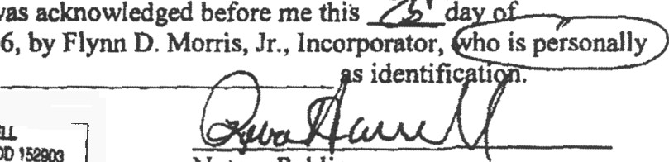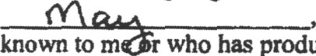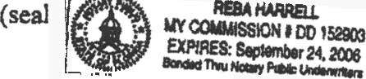
Th¢ foregoing insmoocnt was aclosowledged before me this
2006, by Flynn D. Morris, Jr., lncorporator, o is personally
known to m who has produced identifi u

Notary Public

ACCEPTANCE BY RESIDENT AGENT
The undersigned accepts the appointment as resident agent of the corporation, and agrees to comply with all provisions of the law relating thereto.
DATED this byof O . 20ti6.
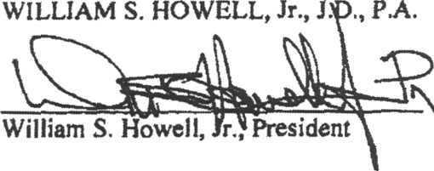
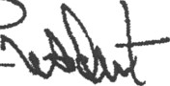
WILLIAM S. HOWELL, Jr., J. ., PM.
William S. Howell, r., Pmiident

