LasdmvkRebOfSciatRrcorRS«mcfi
Inst. 020 $0tht80l9 Bk: 33$2 Pg. 596 Recorded: 3f10f2Il25 2:IRi PM Cmstal Seonitri Clerk of Courts, Walion Count›’, Florida Rec Fees: 518.50 Deput3' Clerk SETZER
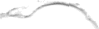

AMENDMENT TO THE COVENANTS, CODES AND RESTRICTIONS FOR EAGLE BAY LANDING HOMEOWNERS ASSOCIATION

THIS AMENDMENT TO DECLARATION OF COVENANTS, CODES and RESTRICTIONS
(this "Amendment") is dated as of their aay off 5, by the EAGLE BAY LANDING HONEOWNERSASSOCIATION, INC., a Ftoridanot-for-profitcorporation (the”Neighborhood Association").The effective date of this Amendment shallbe the date that this Amendment
is recorded in the Public Records of Walton County, Florida (the"EffectiveDate").
RECITALS:
WHEREAS, the owners of the Association have voted to bar home rentals for a period
of less than six (6) months,
NOW, THEREFORE, the Homeowners Association hereby amends the Declaration and the Bylaws as set forth below:

- Prohibition on Rentals less than Six Months: "Homeowners are prohibited from teasing their home for a period tess than six (6) months without the express permission of the Board and only in cases of hardship. This new rule applies to all homeowners who have purchased their property aher this rule is passed."
IN WITNESS WHEREOF, the Homeowners Association has executed this Amendment as
of the date set forth above.
WITNESSES:

PRINT NAI•tE
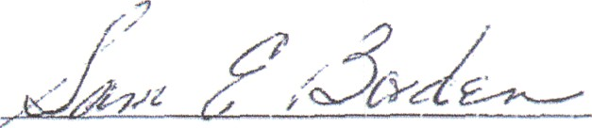

”SIGNATURE

PRINT NANE
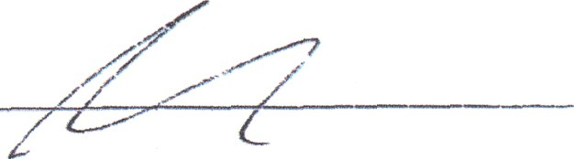

https://orsearch.clerkofcourts.co.wa1ton.II.uslsearcHindex?therne=.blue&sections—nearchCriteñaDocuments&quickSearchSelection=4

IRSt. #2016000033103 Bk: 3022 Pg: 4670 Recorded: 10/11/2016 1:10 PM Alex Alford Clerk of Courts, Walton County, Florida Rec Fees: $78.00 Deput3 Clerk KELLEY

THIS INSTRUMENT PREPARED BY:
Hand Arendall LLC
P.O. Box 123
Mobile, Alabama 36601
( 432 1
STATE OF FLORIDA:
COUNTY OF WALTON:

THIRD AMENDMENT TO DECLARATION OF COVENANTS,

CND
AIONS TTEST
IONEASEMESNTS

OF

EAGLE BAv LANDING

THIS THIRD AMENDMENT TO DECLARATION OF COVENANTS, CONDITIONS, RESTRICTIONS AND EASEMENTS OF EAGLE BAY LANDING (this “Amendment”) is
made and entered into by D.R. HORTON, INC., a Delaware corporation (“DHI”), EB-BAY LOT NO. 1, LLC, a Florida limited liability company (“Lot 1”), EB-BAY LOT NO. 2, LLC, a Florida limited liability company (“Lot 2”), and EB-BAY LOT NO. 3, LLC, a Florida limited liability company (“Lot 3”; Lot 1, Lot 2, and Lot 3 are sometimes collectively referred to as the “Waterfront Lot Owners” and each individually as a “Waterfront Lot Owner”).
Recitals:
WHEREAS, on January 7, 2008, Eagle Bay Landing, Ltd., a Florida limited liability partnership (“Original Declarant”) recorded that certain plat of subdivision for Eagle Bay Landing (the “Subdivision”) in Plat Book 18, Page 28 in the Public Records of Walton County, Florida (the “Public Records”);
WHEREAS, on May 22, 2008, Original Declarant subjected the Subdivision to the terms and conditions of that certain Declaration of Covenants, Conditions, Restrictions and Easements recorded at Official Records Book 2793, Page 1656 in the Public Records, as amended by that certain (i) First Amendment to Declaration of Covenants, Conditions, Restrictions and Easements of Eagle Bay Landing recorded at Official Records Book 2830, Page 1100 in the Public Records, and (ii) Second Amendment to Declaration of Covenants, Conditions, Restrictions and Easements of Eagle Bay Landing recorded at Official Records Book 2891, Page 924 in the Public Records (collectively, the Declaration”);
WHEREAS, on December 14, 2015, Original Declarant assigned all of its rights as “Declarant” under the Declaration to Eagle Bay Lots, LLC, a Florida limited liability company (“EBL”) pursuant to that certain Assignment of Developer/Declarant Rights recorded at Official Records Book 2997, Page 3444 in the Public Records (the “First Assignment”);

2994269_l

WHEREAS, on October d 2016, DHI acquired fifty-three (53) of the fifty-six (56) lots in the Subdivision (or 94.6% of the total lots) from EBL by that certain Special Warranty Deed recorded at Official Records Boo 2- , Page dd in the Public Records (the “DHI Lots”);
WHEREAS, the Waterfront Lot Owners are the owners of the other three (3) lots in the Subdivision (each individually, a “WateJront Lot”, and collectively, the “Waterfront Lots”), which together with the DHI Lots, constitutes 100% of the lots in the Subdivision;
WHEREAS, on October , 2016, following EBL’s conveyance of the DHI Lots to DHI, EBL assigned to DHI all of its rights as Declarant pursuant to the First Assignment by that certain Assignment and Assumption of Declarant's Rights reGorded at Official Records Book
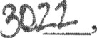 Page in the Public Records (the “Second Assignment”);
WHEREAS, Section 12.4 of the Declaration provides that the Declaration may be amended by (i) recording an amendment executed by the Declarant in the Public Records, provided that such amendment conforms with the general purposes and standards set forth in the Declaration, or (ii) recording an instrument signed by the President of the Eagle Bay Landing Owners Association, Inc., a Florida non-profit corporation (the “Association”) and attested to by the Secretary of the Association that at least 2/3 of all owners of lots within the Subdivision approved of the amendment;
WHEREAS, DHI is the Declarant of the Subdivision pursuant to the Assignment; WHEREAS, the DHI Lots and the Waterfront Lots constitute all of the lots within the
Subdivision, and there are no other individuals or entities that own any lots in the Subdivision other than DHI and the Waterfront Lot Owners; and
WHEREAS, DHI and the Waterfront Lot Owners desire to jointly amend the Declaration in accordance with the terms and conditions hereof.
Amendment:
NOW THEREFORE, DHI, as the Declarant of the Subdivision pursuant to the Assignment and as the owner of the DHI Lots, and the Waterfront Lot Owners, as the owners of the Waterfront Lots, hereby jointly amend the Declaration as follows:
- Capitalized Terms. Capitalized terms used herein unless otherwise defined herein shall have the meaning ascribed to such terms in the Declaration.
- Recitals. The foregoing recitals are true and correct in all material respects and form an integral part of this Amendment, the same as if said recitals were included in the numbered paragraphs hereof.
- Amendment to Section 5.6. The Declaration is hereby amended by deleting the first sentence of the current text of Section 5.6 of the Declaration in its entirety and inserting in lieu thereof the following: “Except as otherwise specified in Section 5.10 hereof, the Annual Assessments for a Parcel shall commence upon substantial completion of that Parcel.”
2994259_t 2

- Amendment to Section 5.10. The Declaration is hereby amended by deleting the current text of Section 5.10 of the Declaration in its entirety and inserting in lieu thereof the following:
Section 5.10. Exempt Property; Declarant Lots Exempt During Declarant Control. Notwithstanding anything herein to the contrary, the following properties subject to this Declaration shall be exempt from all Assessments, charges, and liens created herein, to-wit: (a) all properties dedicated to, and accepted by, a local public authority or utility company and serving a public use; and (b) all properties owned by a charitable or non-profit organization exempt from ad valorem taxation by the laws of the State of Florida. In addition to the foregoing, all Lots owned by Declarant shall be exempt from Assessments of any type by the Association until the first to occur of
  - Declarant's execution and recordation in the real property records of Walton County, Florida of a written waiver of the exemption from the Assessments, or (ii) the termination of the Class B membership in accordance with Section 4.2(b) hereof; provided, however, that for so long as Lots owned by the Declarant are exempt from Assessments, Declarant shall be responsible for and shall pay any and all operating expenses of the Association that exceed the amount of Assessments receivable hereunder from the other Members and other income sources (if any) of the Association.
- Amendment to Section 5.17. The Declaration is hereby amended by deleting the current text of Section 5.17 of the Declaration in its entirety and inserting in lieu thereof the following: “Except as otherwise provided in Section 5.10 hereof, in the event of a shortfall in collected Assessments to cover expenses of the Association, Declarant may, but is not obligated to, make advances to cover all or part of such shortfall to the Association to be repaid on such terms as may be agreed by the Association and Declarant.”
- Amendment to Section 6.9. The Declaration is hereby amended by deleting the current text of Section 6.9 of the Declaration in its entirety and inserting in lieu thereof the following:
Section 6.9. Irrigation. No Owner shall be obligated to install, construct, or maintain any landscaping materials or sprinkler lines or heads within the Common Property that lies in front of an Owner's Lot in the right-of-way between the paved road and such Lot's front yard lot line (the “ROW Landscaping Area”); however, each Owner may elect to install landscaping materials or sprinkler lines or heads and is hereby granted an easement over, across, and under any portion of the ROW Landscaping Area in front of such Owner's Lot for the installation, construction, and maintenance of landscape materials and sprinkler lines and heads, if applicable.

2994259 1 3

- Amendment to Section 7.18. The Declaration is hereby amended by deleting the current text of Section 7.18 of the Declaration in its entirety and inserting in lieu thereof the following:

Section 7.18. Dwellings. The ARB shall establish the minimum square footage for Dwelling Units.
- Amendments to Architectural Design Guidelines. The Declaration includes those certain Architectural Design Guidelines as shown in Exhibit “B” of the Declaration (the “Guidelines”). The Guidelines are amended in accordance with the following:
- Article III, Section K. The Guidelines are hereby amended by adding the following new sentence to the current text of Section K of Article III of the Guidelines to immediately follow the end of the second sentence: “Declarant may waive the ARB fee or any portion thereof for any Lots owned by the Declarant.”
- Article III, Section L. The Guidelines are hereby amended by deleting the current text of Section L of Article III of the Guidelines in its entirety and inserting in lieu thereof the following:

L. [INTENTIONALLY DELETED.]
- Article IV, Section A(3)(e). The Guidelines are hereby amended by deleting the current text of subsection 3(e) of Article IV, Section A in its entirety and inserting in lieu thereof the following:
e. Except for Lots owned by the Declarant, landscape plans showing all existing and proposed vegetation, with irrigation system. Owners should contact the ARB before clearing their Lots, and the ARB may require an Owner to flag any trees and vegetation to be cleared for inspection by an ARB representative. The plan is to preserve as much of the natural vegetation as possible and remove only plants and trees in the house footprint; however, approval of any landscape plans is within the sole discretion of the ARB.
- Article IV, Section C. The Guidelines are hereby amended by deleting the current text of Section C of Article IV of the Guidelines in its entirety and inserting in lieu thereof the following:
C. Construction Commencement. Upon receipt of ARB approval and any applicable permits from the county or other regulatory authority, an Owner may commence construction on its Lot. The ARB reserves the right to inspect in the field for compliance during any stage of construction. All refuse and construction debris shall be kept inside a

2994259_1 4

construction dumpster or similar container or inside the structure and not visible from the street at the end of each day.
- Article V, Section B. The Guidelines are hereby amended by deleting the first sentence of Section B of Article V of the Guidelines in its entirety.

- Article VI, Section A. The Guidelines are hereby amended by deleting the current text of Section A of Article VI of the Guidelines in its entirety and inserting in lieu thereof the following:
  - [INTENTIONALLY DELETED l
- Article VII, Section A(2)(c). The Guidelines are hereby amended by creating the following new subsection 2(c) to immediately follow subsection 2(b) of Article VII, Section A:

- In no way limiting the foregoing, any Lots with diminished building capacity due to the presence of conservation easements, wetlands, or other factors outside of the control of the Owner of the Lot shall not be subject to the minimum total square footage requirements to residences as stated in subsections (a) and (b) above. Declarant shall have the sole and exclusive power to grant and issue waivers with respect to the requirements of subsections (a) and (b) above, in its sole and absolute discretion, and such waiver shall be deemed to have been granted for any Declarant-owned Lots that are improved with a residence that do not meet such minimum square footage requirements.
- Article VII, Section A(5)(a). The Guidelines are hereby amended by deleting the current text the third and fourth sentences of subsection 5(a) of Article VII, Section A of the Guidelines in their entirety.
- Article VII, Section A(5)(d). The Guidelines are hereby amended by deleting current text of subsection 5(d) of Article VI, Section A of the Guidelines in its entirety and inserting in lieu thereof the following:

[INTENTIONALLY DELETED.]
- Waterfront Lot Assessment Exemption. Notwithstanding anything contained in the Declaration or this Amendment to the contrary, each Waterfront Lot shall be exempt from Assessments under the Declaration until the earlier of either (a) the applicable Waterfront Lot Owner no longer owning the Waterfront Lot, or (b) upon a Waterfront Lot Owner obtaining a building permit for a Dwelling Unit on the applicable Waterfront Lot.
- Ratification. The terms and conditions set forth in this Amendment shall modify and supersede all inconsistent terms and conditions set forth in the Declaration, and, except as eKpressly modified and superseded by this Amendment, the terms and conditions of the
2994259_l 5

Declaration are ratified, adopted, and confirmed by all parties hereto and shall continue in full force and effect.
- Continued Effectiveness. All of the applicable terms, conditions and provisions of the Declaration, as hereby supplemented and amended, are in all respects hereby ratified and reaffirmed, and the Declaration and this Amendment shall be read, taken, and construed as one and the same instrument. References in the Declaration and all exhibits thereto shall be deemed to be references to the Declaration as amended by this Amendment. In the event of any conflict or inconsistency between the terms and conditions of the Declaration and the terms and conditions of this Amendment, the terms and conditions of this Amendment shall control in all respects.
- Association Approval or Ratification. It is the intent of the parties hereto that this Amendment be effectuated by both DHI in its capacity as Declarant pursuant to the Assignment and by DHI and the Waterfront Lot Owners jointly as the owners of 100% of the Lots in the Subdivision. DHI and the Waterfront Lot Owners hereby acknowledge that by executing this Amendment in each of their respective capacities as Lot owners who collectively hold 100% of the voting rights of the Members of the Association, the Association is hereby deemed to have ratified and approved of this Amendment without any further action required by the Association, and any and all requirements of Section 12.4 of the Declaration with respect to the procedure and requirements for the Association to effeetuate an amendment to the Declaration are hereby satisfied upon the execution of this Amendment by DHI and the Waterfront Lot Owners.
(Remainder of this page is lefi intentionally blank. j

2994259_l 6

IN WITNESS WHEREOF, DHI has caused this Amendment to be executed by and through its dqly-autho cd repr sentatives as of thc date first set forth above.
Witness D.R. HORTON, INC. elaware corporation

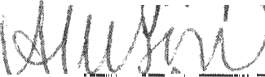
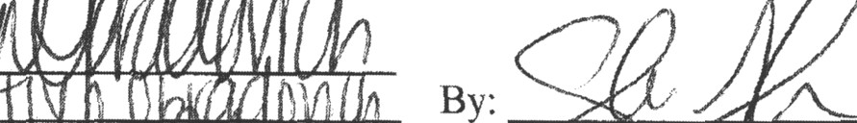

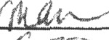
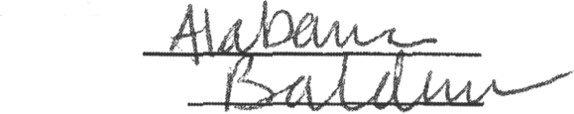

Print N me:
STATE OF COUNTY OF

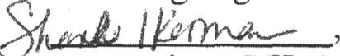
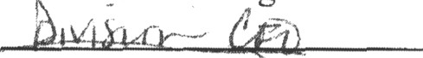

The foregoing
as
corporation. S/He
as identification.

[SEAL]
acknowledged before me this day of October, 2016, by
of D.R. Horton, Inc., a Delaware
11 k to jlne or produced a

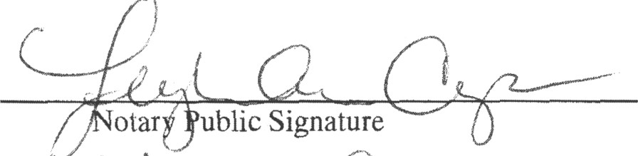

otarJ ublic Signature
» i‹ ,â›n r› «II.
Mary Public Printed Nat

1EI0H ANN CAPOCCI
Notery Public
State of Alabama Commission # 12508
Commlsslon Expires 0/08/2016

7

IN WITNESS WHEREOF, the Waterfront Lot Owners have caused this Amendment to be executed by and through their duly-authorized representatives as of the date first set forth above.
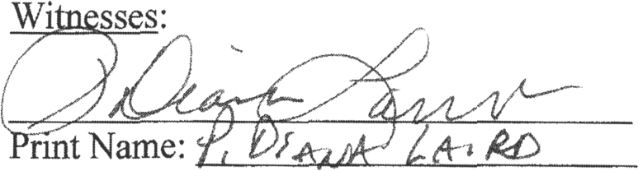
EB-Bay Lot No. 1, LLC, a Florida limited liability company
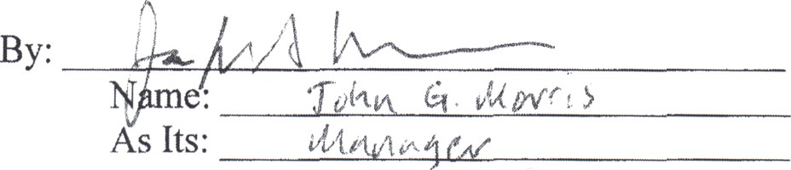
STATE OF
COUNTY OF M+
The foregoing instrument was acknowledged before me this day of October, 2016, by
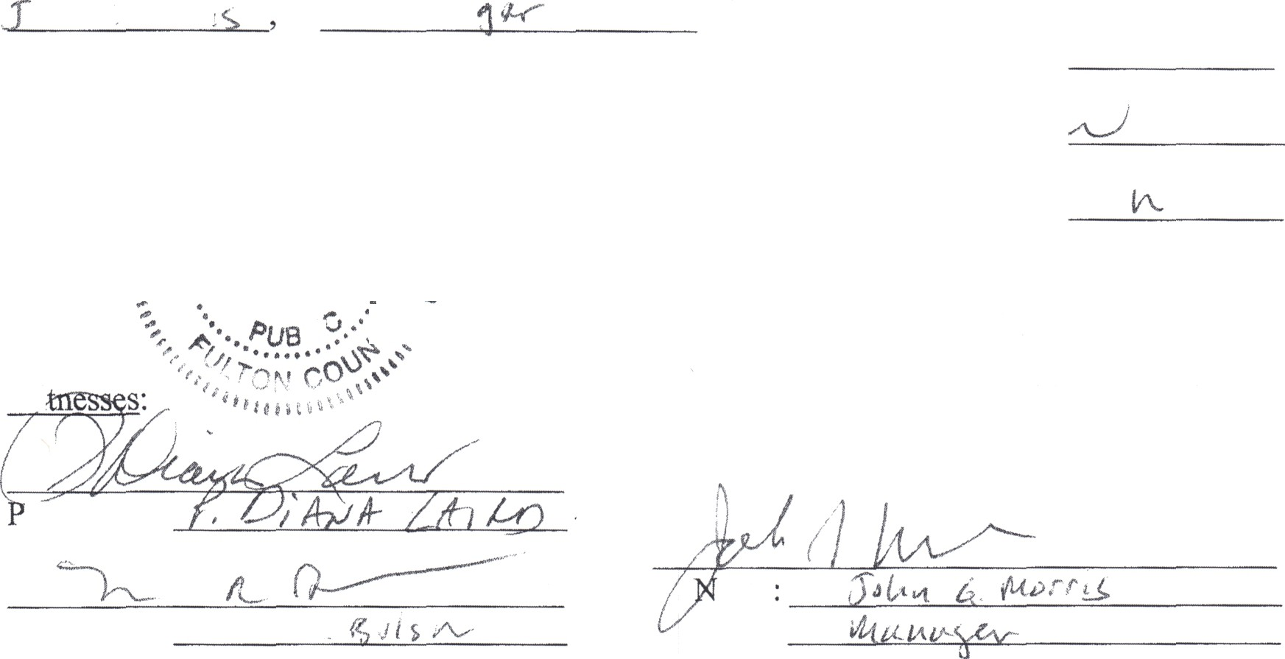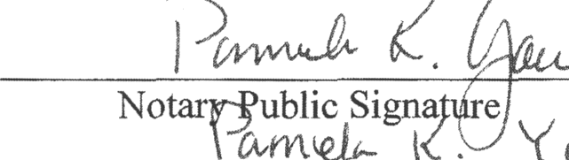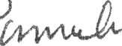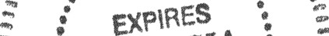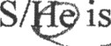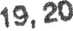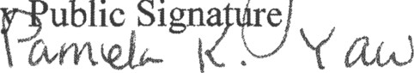
ub^ 4 iW*°.
as
limited liability company. as identification. ,. ,,, „
atau
agpo so
of EB-Bay Lot No. 1, LLC, a Florida
11
of
or produced a
[SEAL] *
-
pzoRGM
Oune
Notary Public Printed Name
Wi
EB-Bay Lot No. 2, LLC, a Florida limited liability company
rint Name:
By:
ame
As Its:

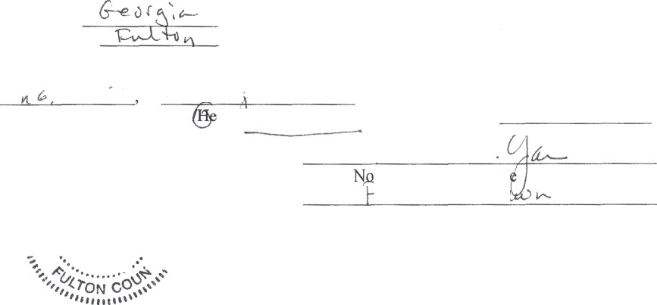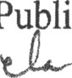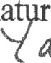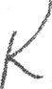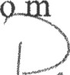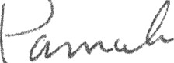
STATE OF COUNTY OF
The foregoing instrument was acknowledged before me this day of October, 2016, by Jra d•w? 1 as it4r_‹ ' of EB-Bay Lot No. 2, LLC, a Florida
limited liability company. S
as identificatiioiinii.i
is Ji'ersonally known t
' '
tary Pu lic igna
•
in
. d
GIA
,
Notary Public Printed Name
2994259 I 7

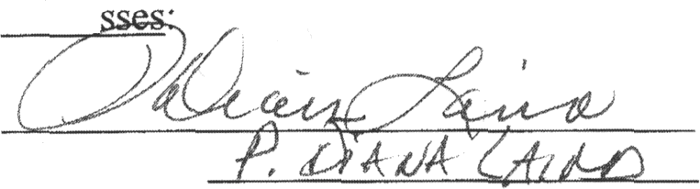
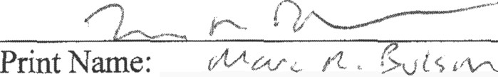
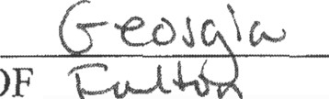
STATE OF M 1
Witne
Print Name:
COUNTY OF

EB-Bay Lot No. 3, LLC, a Florida limited liability company
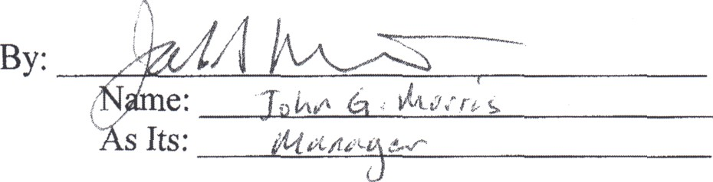

The foregoing instrument was acknowledged before me this day of October, 2016, by
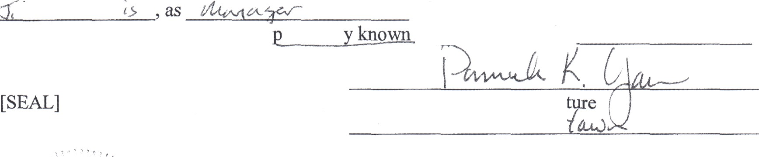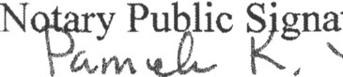
‹/ .« ri› ?/ ‹•‹^
limited liability company. S/
as identification.
is ersonall
of EB-Bay Lot No. 3, LLC, a Florida to me or produced a
Notary Public Printed Name


2994259_l 8

Prepared by and return to:
WILLIAM S. HOWEL , JR.
l727s Co HwY 393
smiABosAazAcu.x32459
THIS SPACE PROVIDED FOR RECORDI1'4G INFORMATION
0

COVENANTS, CONDITIONS, RESTRICTIONS AND EASENk NHS OF

TMRSSECC#NI AhlENDMENTof the
si•¥'enxfiâl szz/t•d’ivicion

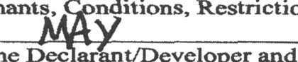
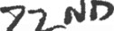
o'F Govezzants, editions, Restrictions and

Easements of EAGLE BAY LANDING is made this day of , 2012, by EAGLE BAY iA2'4DING, LTD. , a Florida limited partnership, as the Dec arant/Developer and holñer of all the Declarant's rights uncter the provisions of the said Declaration of Covenants, Conditions, Restrictions and Easements of Eagle Bay Landing, as recorded in Official Reoorcts Book 2793, at Page 1656- 1715.
wnrncas. mgle BayLan‹:ting, Ltd. as the original DeclaranuDeveloper of Eagle Bay Lancting, caused to be plaoed and imposed upon its lands in Walton County. Florida, that certain Declaration of Covenants, Conditions, Restrictions and Easements with Exhibit “B” thereof, consisting of a set of “Architectural Design Guidelines for Eagle Bay Landing, as recorded in the Pub lie Records of Walton County. Florida, in Official Records Book 2793, at Page 165tS- 17 15, which covers the property described in the Plat of EAGLE Bid LANDD'4G which is recorded in Plat Book 18, Pages 28-28H; and,
WHEREAS. the Declarant/Developer, Eagle Bay Landing, Ltd. desires to amend a portion Exhibit “B”, the Architectural Design Gui‹ielines of the said Declaration to provide that the minimum size of heated and cooled area of a one story residence shall b'e l ,600 square feet, arid the heatect and cooled area of a two story house shall be 1,900 square feet and; and,
NOW, THEREFORE, in corisideration of the aforementioned premises, pursuant to the authority reserved to the Declarant in the Declaration of Covenants, Conditions, Restrictions and Easements of Eagle Bay Landing, to amend the saxrie, it is hereby declared that Article VII, A. (2) (a) and (b) of the Eagle Bay Landing Architectural Design Guidelines are amended to read as follows, to-wit:

VIL BU€rOINGGUIDFIINxSAIWI}ARCIMTXCTURALSTAJMDAPLDS
A. SINGLE FAMILY RESIDEJ‘stCE.
- Square Footage
  - Att one story residences shall have minimum total square footage (treated an‹:1 coole‹I) r sixteen Hundred ( t ,600) square feat.
  - All two story residences shall have minimum total square footage(heated and cooled)
ofNinemsnHundred(,90O)sq efesL

Page 1 o f 4

Except as expressly amended by this amendment. the Declaration of Covenants, Conditions Restrictions aod Easmnena ofEagla Bay Landing including the Acckitocturat Oesign Guidelines ekatt remaizt ia f\z1l home and ct' ect as originally recorded. This Ameftdment ghall run with the title to the Property listed in Exhibit “A" (as defined in the declaration) and will bind anct inure to the benefit of the owners thereof.
zzv wr¥wEss wuzzzzoy, mc »au<w gas. Oeclarant7ocveloper of the Eagle Bay Landing rcsidutzLiat subdJviaiozz, as pemzittad and authorized by tbe said Declazatioa of the eaid subdivisions, do ametzd the declaration we stated herein. This Amendment shall become effective upon its recording in the Public Records of Walton County, Florida.

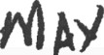
Dated this dsy of .2012.

stem, SRALED A2"iD DELIVERED It'4 THE PRESH ICE OF:
EAGLEBAYLANDING,L
a Florida Lirriited Paruimhip

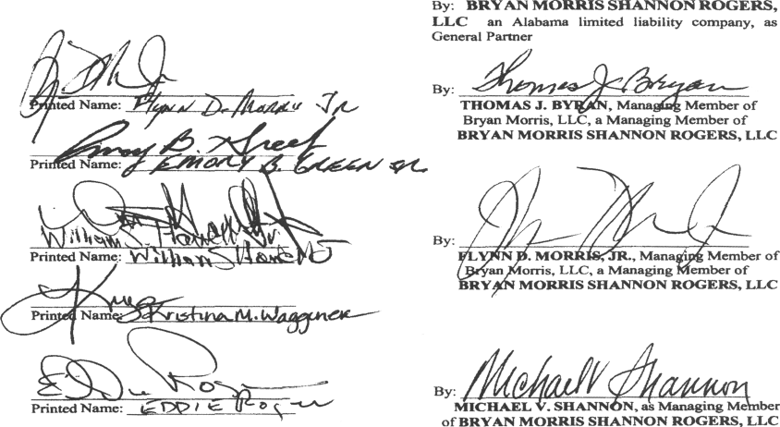
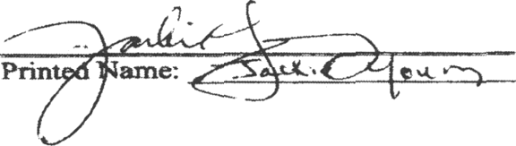

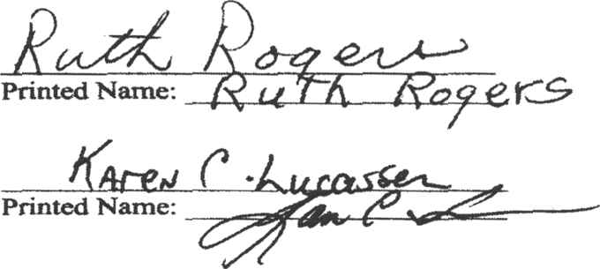

STATE OF 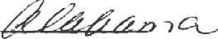
CO£II ITY 0 ”


Thy foregoing insfzurrwnt was acknowle<ige<i before rric this day of . 2012, by
EDWARD '•.&OCrERS, asMminging Merntrer ofBRYAm MORRIS SHAMt"4ON ROGERS, LLC, Alabama limited
1 th Gen P•rmcr $ BAY L.Ai9DTf•iG. LTO.. who is personally kziown to me or who hes
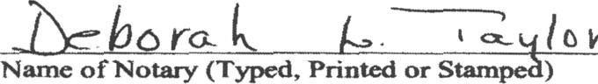
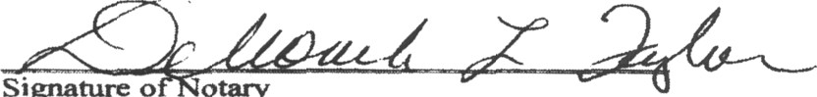
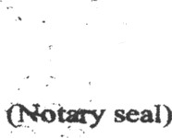

Wartic of l'4ota4y (Typed, Printed or Stars ) Commieeion Number: (if not legible on cell) My Commission Expires: (if not legible on seal)

My Commission Expires08/21/2.Q12


STATE OF

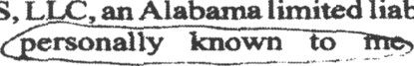
The foregoing iriatrunwnt waa acknowledged before me chis IN day of I , 2012, by T¥gOñg,AS 7. BANK, as Mezragtng Membor oJ° BRYA "I MORRIS, PLC, aa Mabaxna Juzuted tiah›ttcy ro-party. a m «a r ozaRY MOReIS S+tAuxiOx ROGERS, L aa Alabama ti att•d tiahility co••pany, tic Gc•azai
iTD.,
who i mDnsGy
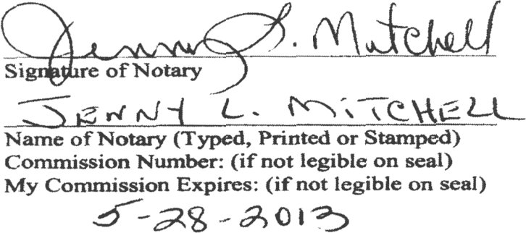

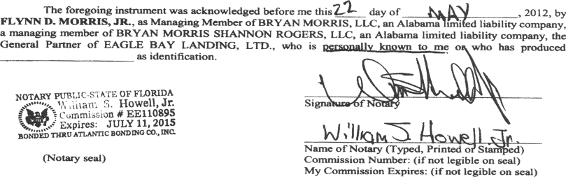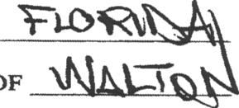
COUNTYOF



COUNvYOF
The foregoing instrument was acknowleñgeñ before me this I day of

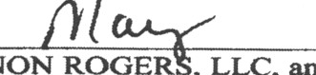
, 2012, by

MICHAEL V. UNAJ 4)"4ON, as Managing Member of BRYAN MORRIS SHAN1'4ON ROCiER , LLC, an Alabama limited liability company, the General Partner of EAGLE BAv i. fDING. LTD., who ifly o wh° h•sP•°#Uccd /# ss idenñfcaGon.
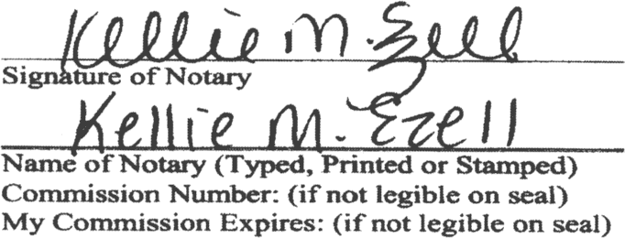

Page4 of 4

CFN # 1099854, OR BK 2830 Page 1100, Recorded 11/20/2009 at 08:08 AM, MARTHA
INGLE, WALTON COUNTY CLERK OF COURT Deputy Clerk S SUTERA

Prepared by aad retura to:
WILLIAM S. HOWELL, JR.
ATTORNEY AT LAW
1727 s. Co. HWY. 393
SANTA ROSA BEnCH, FL 32459
THIS SPACE PROVIDED FOR RECORDING INFORMATION

FIRST AMENDMENT TO DECLARA'FION OF COVENANTS, CONDITIONS, RESTRICTIONS AND EASEMENTS OF

EAGL.E BAY LANDING, a residenfinf subdivision
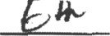

THIS FIRST AMENDMENT of the Declaration of Covenants Conditions, Restrictions and
Easements of EAGLE BAY LANDING is made this day of , 2009,
by EAGLE BAY LANDING, LTD. , a Florida limited partnership, as the Declarant/Developer and holder of all the Declarant’s rights under the provisions of the said Declaration of Covenants, Conditions, Restrictions and Easements of Eagle Bay Landing, as recorded in Official Records Book 2793, at Page 1656.
WHEREAS, Eagle Bay Landing, Ltd. as the original Declarant/Developer of Eagle Bay Landing, caused to be placed and imposed upon its lands in Walton County, Florida, that certain Declaration of Covenants, Conditions, Restrictions and Easements of Eagle Bay Landing, a residential subdivision, as recorded in the Public Records of Walton County, Florida, in Official Records Book 2793, at Page 1656, which covers the property described in the Plat of EAGLE BAY LANDING which is recorded in Plat Book 18, Pages 28-28H; and,
WHEREAS, the Declarant/Developer, Eagle Bay Landing, Ltd. desires to amend the said Declaration to provide that the three residential lots situated on the northern boundary of Eagle Bay Landing which are owned by the said DeveloperfDeclarant shall be bound by all of the obligations, responsibilities, and burdens of the owners of all lots in Eagle Bay Landing, and shall have all of the rights and benefits enjoyed by the owners of all lots in Eagle Bay Landing , including but not limited to use of common areas, and easements held by the Eagle Bay Landing Homeowners Association, Inc. as designated to it in the subject Declaration for Eagle Bay Landing., and which three lots are subject to the obligations to pay assessments to the Eagle Bay Landing Homeowners Association, Inc. as if included in the original Plat of Eagle Bay Landing; and,
WHEREAS, the Declarant/Developer, pursuant to the authority retained to amend said Declaration desires to amend the said Declaration as follows:.
NOW, THEREFORE, in consideration of the aforementioned premises, pursuant to the authority reserved in the Declaration of Covenants, Conditions, Restrictions and Easements of Eagle Bay Landing, it is hereby declared that:
- That the three(3) residential lots which are legally described in Exhibit “A” attached hereto and incorporated by reference herein, all of which are adjacent to and joining the boundaries of Eagle Bay Landing, are hereby declared to be subject to all of the Covenants, Conditions, Restrictions and Easements of Eagle Bay Landing as set forth in that Declaration which is recorded in the Public Records ofi Walton County, Florida in Official Records Book 2793, at Page 1656, and the benefits and obligations set forth therein, and that the three lots shall have all of the same rights and obligations as members/owners of lots
Page 1 of 4

included in the original Plat of Eagle Bay Landing, and shall be subject to any changes in those rights and obligations contained in any future amendments to the said Declaration.
- Except as expressly amended by this amendment, the Declaration of Covenants, Conditions Restrictions and Easements of Eagle Bay Landing remain in full force and effect as originally recorded. This Amendment shall run with the title to the Propeny listed in Exhibit “A" (as defined in the Declaration) and will bind and inure to the benefit of the owners thereof.

IN WITNESS WHEREOF, the undersigned, Declarant/Developer of Eagle Bay Landing, as permitted and authorized by the said Declaration of the said subdivision, do amend the Declaration as stated herein. This Amendment shall become effective upon its recording in the Public Records of Walton County, Florida.

Dated this day of I'' JñP , 2009.

SIGNED, SEALED AND DELIVERED IN THE PRESENCE OF:

EAGLE BAY LANDING, LTD.
a Florida Limited Partnership

By: BRYAN MORRIS SHANNON ROGERS,
LLC an Alabama limited liability company, as
General Partner

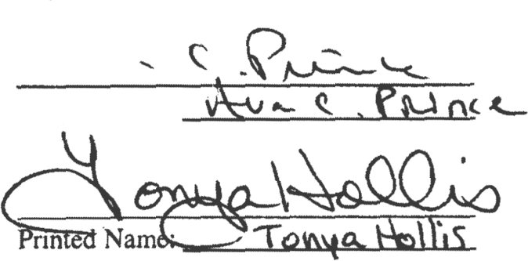
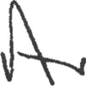
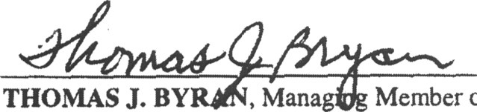
By:

THOMAS J. BY , Mana Member of
Bryan Morris, LLC, a Managing Member of
BRYAN MORRIS SHANNON ROGERS, LLC

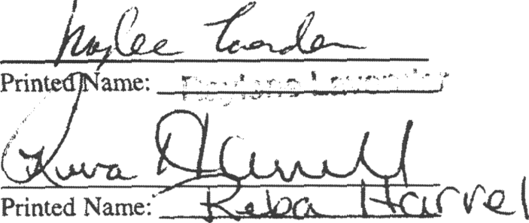
By’

FLY D ORRIS, JR., Managing Member of Morris, LLC, a Managing Member of
RY N MORRIS SHANNON ROGERS, LLC

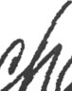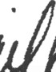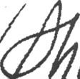
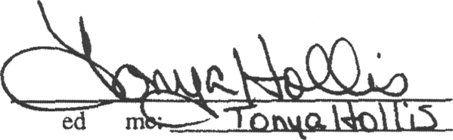
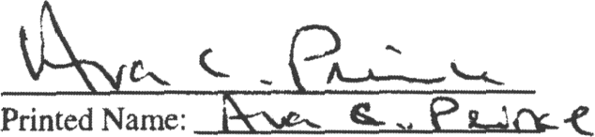
MICHAEL V. SHANNON. as Managing Member of BRYAN MORRIS SHANNON ROGERS, LLC

Priiit Na

Page 2 of 4

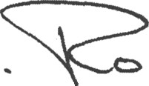
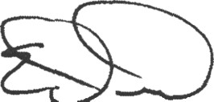
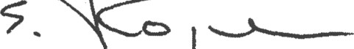
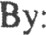
EDWARD E. ROGERS, as Managing Member of BRYAN MORRIS SHANNON ROGERS, LLC

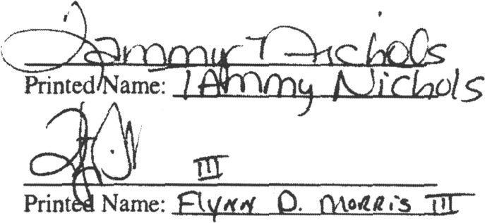
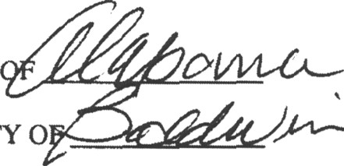
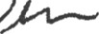
STATE D

COUNTY O

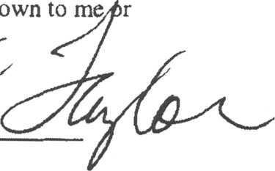
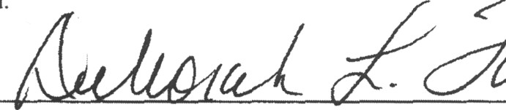
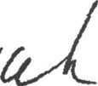
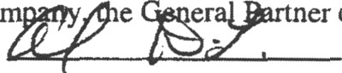
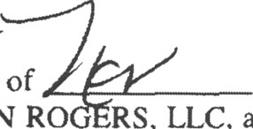
The foregoing instrument was acknowledged before me this day of , 2009. by EDWARD E. ROGERS, as Managing Member of BRYAN MORRIS SHANNON RO RS, LLC, an Alabama limited liability co e er er of EAGLE BAY LANDING, LTD., who is personally known to me r who has produced ’ as identification.



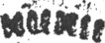


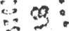







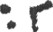

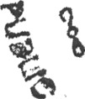
”
(seal)
*.
Signature of Notary
Mg COlTlmisSion Expires 08/2J/20a 2 Name of Notary (Typed, Printed or Stamped) Commission Number: (if not legible on seal)
My Commission Expires: (if not legible on seal)

COUNTY OF €
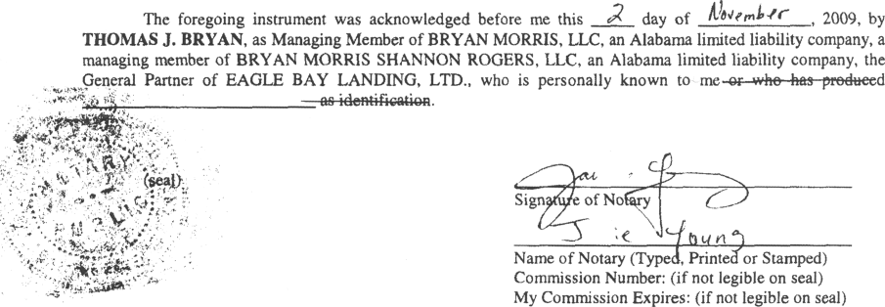
M c0ñMlSSl0fi E«’IA *! *•
Page 3 of 4

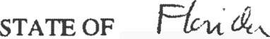
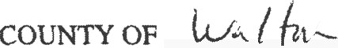

The foregoing instrument was acknowledged before me this day of w , 2009, by FLYNN
D. MORRIS, JR., as Managing Member of BRYAN MORRIS, LLC, an Alabama limited liability company, a managing member of BRYAN MORRIS SHANNON ROGERS, LLC, an Alabama limited liability company, the General Partner of EAGLE BAY LANDING, LTD.pwho is personally known to me or who has produced
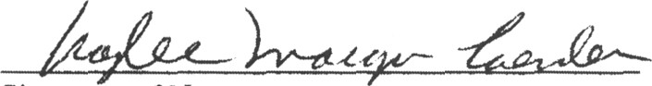
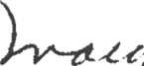
as identification.

(seal)

N0TAitY PUpLIC-SjA@ t3t’ pjQg{p$
* Expires: >nY 04, i01z

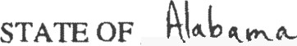

COUNTY OF NC.

Signature of Notary
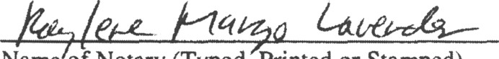
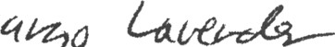

Name of Notary (Typed. Printed or Stamped)
Commission Number: (if not legible on seal) My Commission Expires: (if not legible on seal)

The foregoing instrument was acknowledged before me this day of U , 2009, by MICHAEL V. SHANNON, as Managing Member of BRYAN VORRIS SHANNON ROGERS, LLC, an Alabama limited liability company, the General Partner of EAGLE BAY LANDING, LTD., who is personally known to me wr-
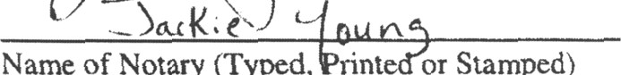
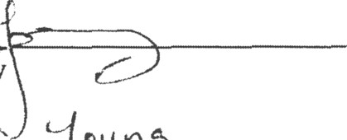
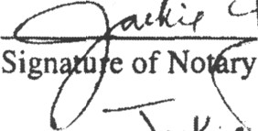




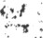



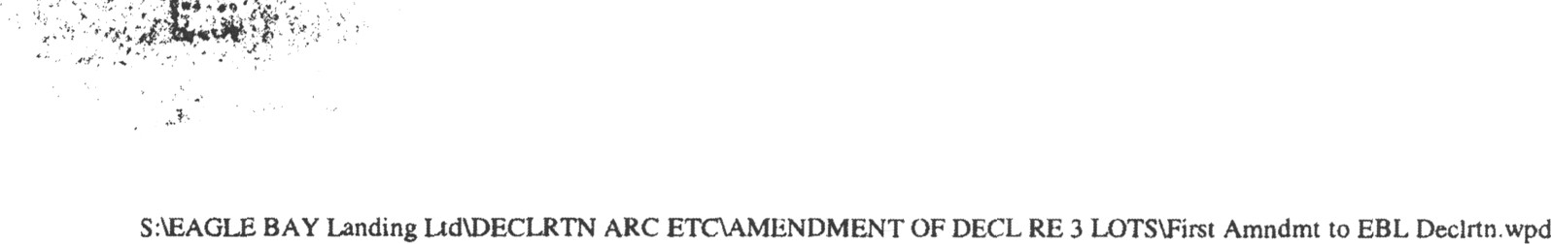

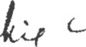

Sign e of No

Name of Notary (Typed, rint or Stamped) Commission Number: (if not legible on seal) My Commission Expires: (if not legible on seal)
II t'00Mssi0ti units mi;. i, 2011

Page 4 of 4

EXHIBIT “A” PARCEL ‘A’ - Tax I.D. No. 20-2S-20-33000-003-0030
A PARCEL OF LAND IN SECTION 20, TOWNSHIP 2 SOUTH, RANGE 20 WEST, WALTON COUNTY, FLORIDA; BEING MORE PARTICULARLY DESCRIBED AS FOLLOWS:

COMMENCE AT THE SOUTHWEST CORNER OF THE SOUTHEAST QUARTER OF SECTION 20, TOWNSHIP 2 SOUTH, RANGE 20 WEST, WALTON COUNTY, FLORIDA; THENCE ALONG THE WEST LINE OF THE SOUTHEAST QUARTER PROCEED NORTH 00 DEGREES 00 MINUTES 24 SECONDS EAST, A DISTANCE OF 1315.95 FEET TO THE SOUTHWEST CORNER OF THE NORTHWEST QUARTER OF THE SOUTHEAST QUARTER; THENCE SOUTH 89 DEGREES 40 MINUTES 29 SECONDS EAST, A DISTANCE OF 332.91 FEET; THENCE NORTH 00 DEGREES 00 MINUTES 06 SECONDS EAST, A DISTANCE OF 872.06 FEET; THENCE SOUTH 89 DEGREES 48 MINUTES 30 SECONDS EAST, A DISTANCE OF 216.45 FEET TO THE POINT OF BEGINNING; THENCE NORTH 00 DEGREES 00 MINUTES 08 SECONDS EAST, A DISTANCE OF 406.7 FEET, MORE OR LESS, TO THE SHORELINE OF CHOCTAWHATCHEE BAY; THENCE MEANDER ALONG SAID SHORELINE EASTERLY A DISTANCE OF 117 FEET, MORE OR LESS; THENCE SOUTH 00 DEGREES 00 MINUTES 08 SECONDS WEST, A DISTANCE OF 400.0 FEET, MORE OR LESS; THENCE NORTH 89 DEGREES 48 MINUTES 30 SECONDS WEST, A DISTANCE OF 116.47 FEET TO THE POINT OF BEGINNING OF THE PARCEL HEREIN DESCRIBED.

PARCEL ‘B’ — Tax I.D. No. 20-2S-20-33000-003-0020
A PARCEL OF LAND IN SECTION 20, TOWNSHIP 2 SOUTH, RANGE 20 WEST, WALTON COUNTY, FLORIDA; BEING MORE PARTICULARLY DESCRIBED AS FOLLOWS:
COMMENCE AT THE SOUTHWEST CORNER OF THE SOUTHEAST QUARTER OF SECTION 20, TOWNSHIP 2 SOUTH, RANGE 20 WEST, WALTON COUNTY, FLORIDA; THENCE ALONG THE WEST LINE OF THE SOUTHEAST QUARTER PROCEED NORTH 00 DEGREES 00 MINUTES 24 SECONDS EAST, A DISTANCE OF 1315.95 FEET TO THE SOUTHWEST CORNER OF THE NORTHWEST QUARTER OF THE SOUTHEAST QUARTER; THENCE SOUTH 89 DEGREES 40 MINUTES 29 SECONDS EAST, A DISTANCE OF 332.91 FEET; THENCE NORTH 00 DEGREES 00 MINUTES 0d SECONDS EAST, A DISTANCE OF 872.06 FEET; THENCE SOUTH 89 DEGREES 48 MINUTES 30 SECONDS EAST, A DISTANCE OF 100.00 FEET TO THE POINT OF BEGINNING; THENCE NORTH 00 DEGREES

00 MINUTES 08 SECONDS EAST, A DISTANCE OF 400 2 FEET, MORE OR LESS, TO THE SHORELINE OF CHOCTAWHATCHEE BAY; THENCE MEANDER ALONG SAID SHORELINE EASTERLY A DISTANCE OF 112 FEET, MORE OR LESS; THENCE SOUTH 00 DEGREES 00 MINUTES 08 SECONDS WEST, A DISTANCE OF 406.7 FEET, MORE OR LESS; THENCE NORTH 89 DEGREES 48 MINUTES 30 SECONDS WEST, A DISTANCE OF 116.45 FEET TO THE POINT OF BEGINNING OF THE PARCEL HEREIN DESCRIBED.

PARCEL C’ — Tax I.D. No. 20-2S-20-33000-003-0010
A PARCEL OF LAND IN SECTION 20, TOWNSHIP 2 SOUTH, RANGE 20 WEST, WALTON COUNTY, FLORIDA; BEING MORE PARTICULARLY DESCRIBED AS FOLLOWS:
COMMENCE AT THE SOUTHWEST CORNER OF THE SOUTHEAST QUARTER OF SECTION 20, TOWNSHIP 2 SOUTH, RANGE 20 WEST, WALTON COUNTY, FLORIDA; THENCE ALONG THE WEST LINE OF THE SOUTHEAST QUARTER PROCEED NORTH 00 DEGREES 00 MINUTES 24 SECONDS EAST, A DISTANCE OF 1315.95 FEET TO THE SOUTHWEST CORNER OF THE NORTHWEST QUARTER OF THE SOUTHEAST QUARTER; THENCE SOUTH 89 DEGREES 40 MINUTES 29 SECONDS EAST, A DISTANCE OF 332.91 FEET; THENCE NORTH 00 DEGREES 00 MINUTES 06 SECONDS EAST, A DISTANCE OF 872.06 FEET TO THE POINT OF BEGINNING; THENCE NORTH 00 DEGREES 00 MINUTES 06 SECONDS EAST, A DISTANCE OF 452.2 FEET, MORE OR LESS, TO THE SHORELINE OF CHOCTAWHATCHEE BAY; THENCE MEANDER ALONG SAID SHORELINE SOUTHEASTERLY A DISTANCE OF 116 FEET, MORE OR LESS; THENCE SOUTH 00 DEGREES 00 MINUTES 08 SECONDS WEST, A DISTANCE OF 400.2 FEET, MORE OR LESS; THENCE NORTH 89 DEGREES 48 MINUTES 30 SECONDS WEST, A DISTANCE OF 100.00 FEET TO THE POINT OF BEGINNING OF THE PARCEL HEREIN DESCRIBED.

S:\EAGLE BAY Landing Ltd\BAYFRONT LOT SURVEYS AND LEGALS (3)\Combined 3 parcels for Exh A to armd declrtn 2009.doc

